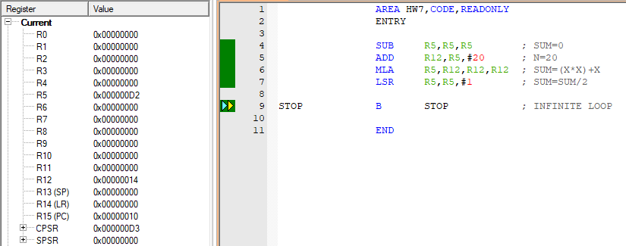

B STOP

LSR R5, R5, #1

HW7

SUB R5, R5, R5

ADD R12, R5, #20

MLA R5, R12, R12, R12

SUM=0

N=20

SUM=SUM/2

SUM=(N\*N)+N

WAIT

HW7